**Algorithms and Data Structures**

Occurrences Counter

**Students:**

Isadora Loredo – 91322-50%

Margarida Martins – 93169-50%

31th of December 2019

Index

The Assignment 2

Implementation 3

**manipulate_file.h** 3

**hash_size** 3

**file_data_t** 3

**word_stats** 3

**open_text_file()** 4

**close_text_file()** 4

**read_word()** 5

**hash_function()** 5

**hash_data** 6

**new_hash_data()** 6

**hash_resize()** 6

**hash_data_bt** 7

**new_hash_data_bt()** 7

**hash_resize_bt()** 8

**traverse_tree()** 8

**insert_bt()** 9

**Linked List** 10

**Binary Tree** 11

Word statistics of text file 12

**Number of occurrences** 12

**First and last appearances** 13

**Smallest, medium and largest distance** 14

**Time of execution and resize** 15

# The Assignment

Count the number of occurrences of each word of a text file (book Sherlock Holmes – A Study In Scarlet), records the location of the first and last occurrences of each distinct word and records the smallest, largest, and average distances between consecutive occurrences of the same distinct word.

The program must use a **hash table** (separate chaining), the hash table size should grow dynamically, and each hash table entry should point to either a **linked list** or an ordered **binary tree**.

# Implementation

## **manipulate_file.h**

The header file ‘manipulate_file.h’ contains functions declaration and data structures that are used by both ‘c’ programs, with linked list and with binary tree, through the directive **#include**.

### **hash_size**

Global variable used to define the size of the **hash table**.



### **file_data_t**

The new data type struct ‘file_data_t’ defines the stats of the text file read and its words.

* long word_pos: position of the current word being read in the file;
* long word_num: number of words read in the file;
* char word[]: array of characters meaning the current word being read in the file;
* FILE *fp: file pointer pointing to the file being accessed;
* long current_pos: current position in the file for the read word;

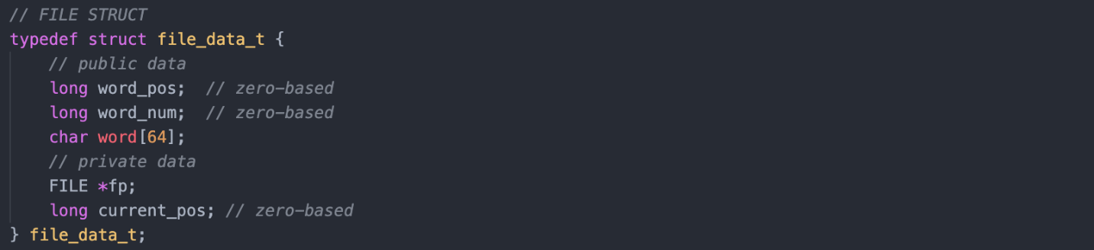

### **word_stats**

The new data type struct ‘word_stats’ defines the stats of each word read by the text file.

* int number_occurrences: number of occurrences of the word in the file;
* int first_appearance: first appearance of the word in the file;
* int last_appearance: last appearance of the word in the file;
* int s_distance: smallest distance between consecutive occurrences of the same distinct word;
* int l_distance: largest distance between consecutive occurrences of the same distinct word;
* int m_distance: medium distance between consecutive occurrences of the same distinct word, so the average distance can be calculated;
* int t_distance: total distance between consecutive occurrences of the same distinct word;

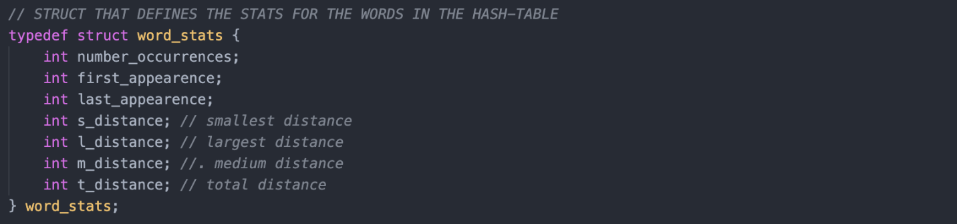

### **open_text_file()**

The function ‘open_text_file’ is used to open the file to be read and also initialize the variables of the data type ‘file_data_t’.

Arguments:

* char *file_name: file pointer pointing to the text file to be accessed;
* file_data_t *fd: file stats pointer pointing to the struct to be initialized;

Return:

* int *value*: returns a integer value, ‘0’ if success or ‘-1’ if file stats pointer is null;

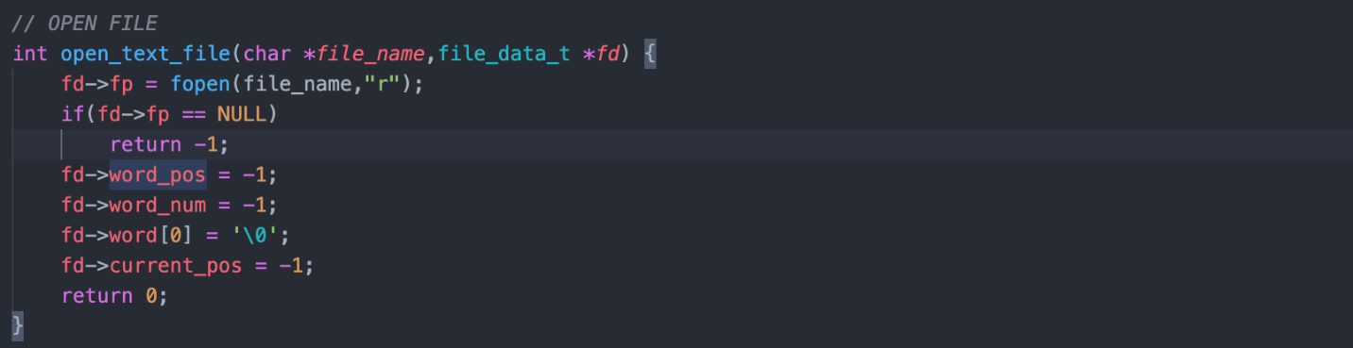

### **close_text_file()**

The function ‘close_text_file’ is used to close the file read.

Arguments:

* file_data_t *fd: file stats pointer pointing to the struct to be initialized;

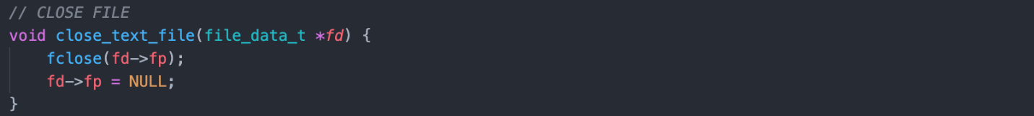

### **read_word()**

The function ‘read_word’ is called to read the next word of the accessed file and save update its stats. It reads each character of the file using white spaces, special characters and punctuations to identify the beginning and end of a word. The characters of the read words are passed to lower case so same words are not detected as different.

Arguments:

* file_data_t *fd: file stats pointer pointing to the struct of the file being accessed;

Return:

* int *value*: returns a integer value, ‘-1’ if end of file reached or 0’ if end of file still not reached;

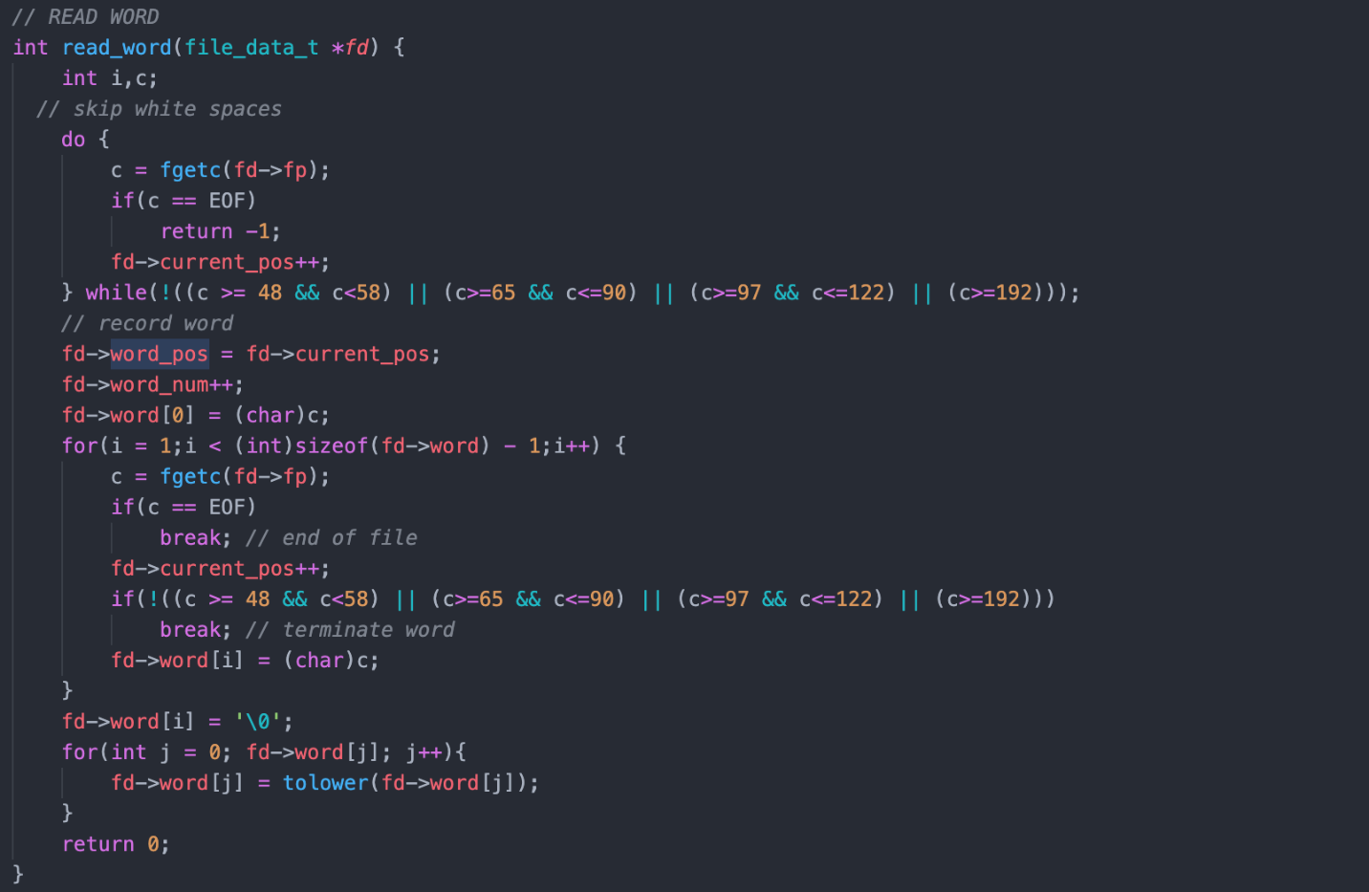

### **hash_function()**

The function ‘hash_function’ maps each possible key (word of the file) to an integer. The integer will then be used to access the **hash table** array, as the index to the array.

Arguments:

* const char *str: the key (word) to me mapped;
* unsigned int s: size of the hash table;

Return:

* unsigned int *value*: calculated value as the index to the hash table;

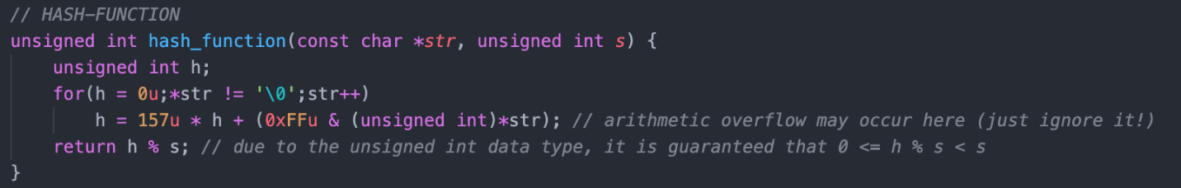

### **hash_data**

The new data type struct ‘hash_data’ defines the nodes of data to be inserted in the **hash table** to the **linked list** implementation.

* struct hash_data *next: pointer to the next node in the linked list;
* char key[]: word read in the file;
* struct word_stats word: stats of the word (key);

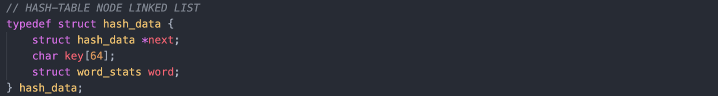

### **new_hash_data()**

The function ‘new_hash_data’ initializes a new hash_data type struct, new node, allocating the necessary memory size.

Return:

* hash_data *hd: pointer to the start location to the initialized node;

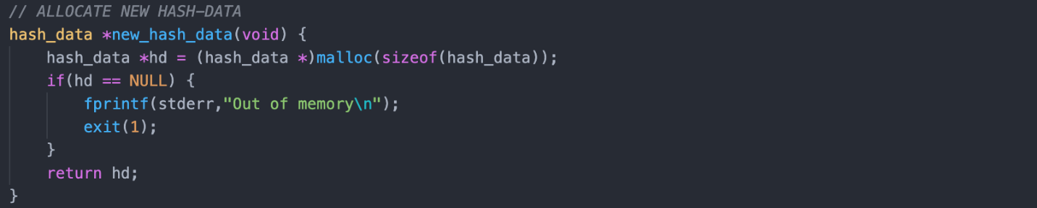

### **hash_resize()**

The function ‘hash_resize’ is called when the **hash table** reaches a certain number of nodes to be inserted and has to grows to avoid a great number of collisions and unwanted too large **linked lists**. It allocates the necessary memory to the hash table with its new size then initializes its null nodes. Finally goes through the old hash table and its linked lists and recalculates the index of each node’s key to relocate them in the new resized hash table.

Arguments:

* hash_data **hash_table: pointer pointing to the address that points to the beginning of the **hash table;**
* unsigned int inc: value of the increment to be added to the hash size;

Return:

* hash_data **hash_data: pointer pointing to the address that points to the beginning of the **hash table** with the increased size;

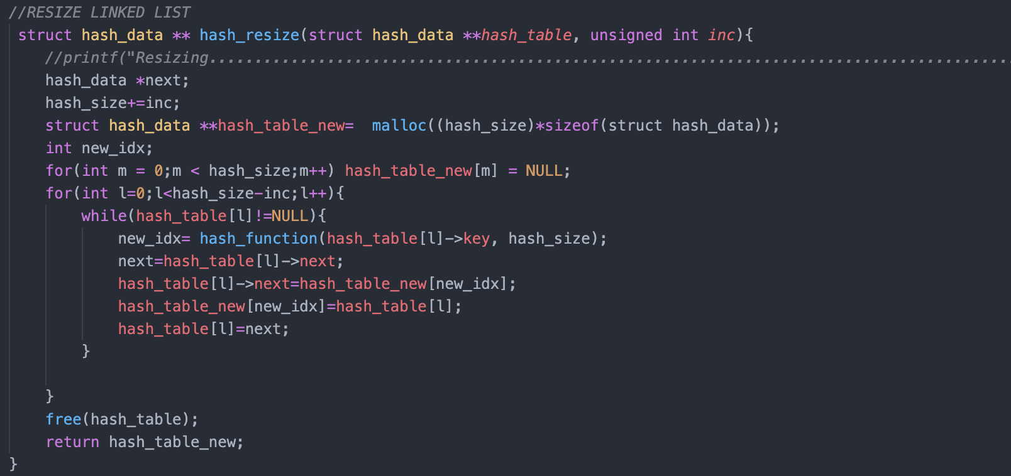

### **hash_data_bt**

The new data type struct ‘hash_data_bt’ defines the nodes of data to be inserted in the **hash table** to the **binary tree** implementation.

* struct hash_data *left: pointer to the node on the left side (the left branch);
* struct hash_data *right: poin pointer to the node on the right side (the right branch);
* char key[]: word read in the file;
* struct word_stats word: stats of the word (key);

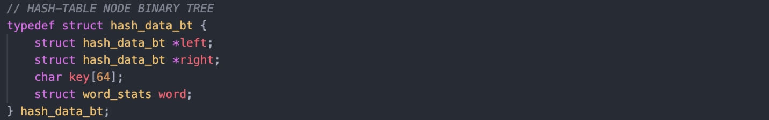

### **new_hash_data_bt()**

The function ‘new_hash_data_bt’ initializes a new hash_data_bt type struct, new node, allocating the necessary memory size.

Return:

* hash_data *hd: pointer to the start location to the initialized node;

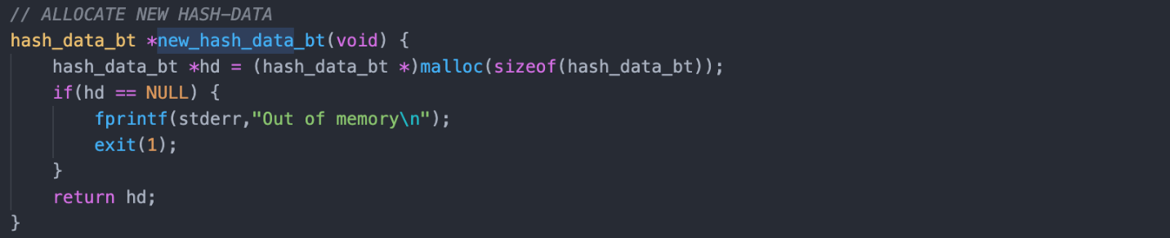

### **hash_resize_bt()**

The function ‘hash_resize_bt’ is called when the **hash table** reaches a certain number of nodes to be inserted and has to grows to avoid a great number of collisions and unwanted too large **binary trees**. It allocates the necessary memory to the hash table with its new size then initializes its null nodes. Finally goes through the old hash table and its binary trees and recalculates the index of each node’s key to relocate them in the new resized hash table.

Arguments:

* hash_data_bt **hash_table: pointer pointing to the address that points to the beginning of the **hash table;**
* unsigned int inc: value of the increment to be added to the hash size;

Return:

* hash_data_bt **hash_data: pointer pointing to the address that points to the beginning of the **hash table** with the increased size;

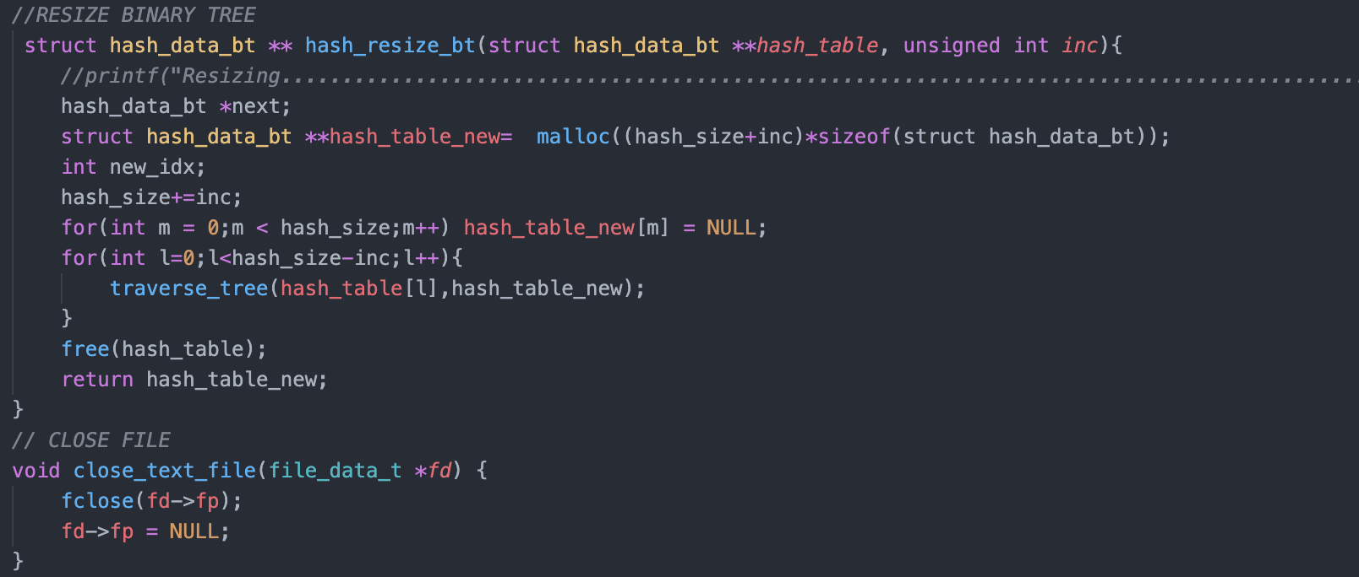

### **traverse_tree()**

The function ‘traverse_tree’ is called when is necessary to perform visits in the **binary trees**. The visits are made using depth-first search recursively. It performs the traverse search, then it calculates the new index of the given node in the resized hash table and if the calculated index has still no allocated node it allocates it as the root of a new tree, otherwise it calls the function to insert the node in the tree.

Arguments:

* hash_data_bt *hb: pointer pointing to the node to be inserted in the resized **hash table;**
* hash_data_bt **hash_table: pointer pointing to the address that points to the beginning of the resized **hash table;**

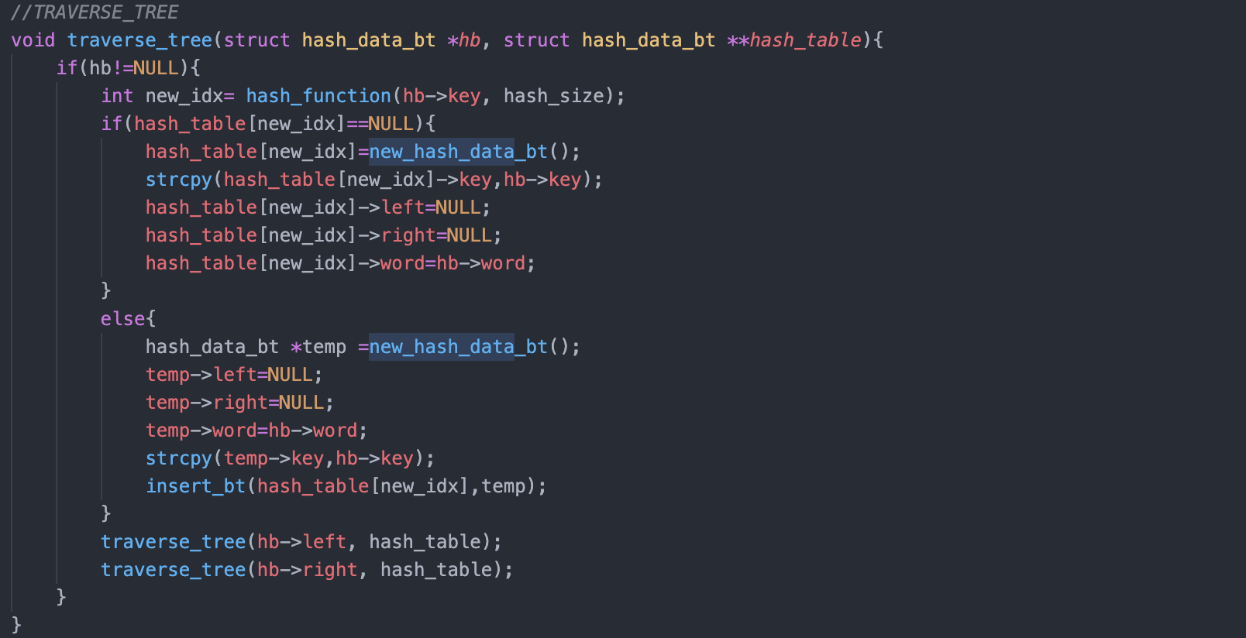

### **insert_bt()**

The function ‘insert_bt’ is called when is necessary to insert a new node in the **binary tree** at the appropriate location, and it is done recursively. It receives the root node and the node to be inserted as arguments, it compares the keys (word) of the arguments so it can insert the node or keep going forward until it finds the proper leaf to insert it as it’s child.

Arguments:

* hash_data_bt *root: pointer pointing to the node to be inserted in the resized **hash table;**
* hash_data_bt *hd: pointer pointing to the address that points to the beginning of the resized **hash table;**

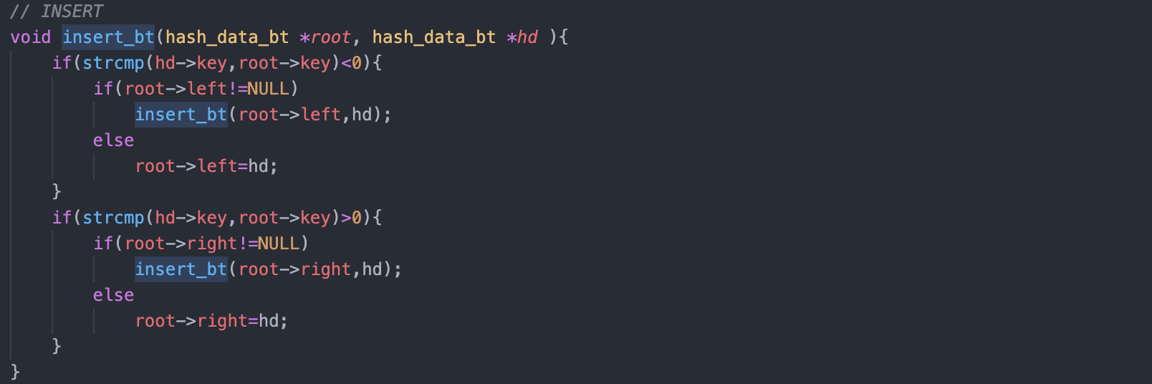

## **Linked List**

The first solution implemented uses a hash table that grows dynamically and each hash table entry points to a linked list when a collision occurs.

The structure *\*hd* is the node to be stored to the hash table, before it does it’s index is calculated using a [hash function](#_hash_function()). The word’s stats are stored, location of the first and last occurrences and the smallest, largest and average distances between consecutive occurrences. It also counts the number of occurrences of each distinct word in the text file and the number of times the hash table is resized.

## **Binary Tree**

The second solution implemented uses a hash table that grows dynamically and each hash table entry points to an ordered binary tree when a collision occurs.

The structure *\*hd* is the node to be stored to the hash table, before it does it’s index is calculated using a [hash function](#_hash_function()). The word’s stats are stored, location of the first and last occurrences and the smallest, largest and average distances between consecutive occurrences. It also counts the number of occurrences of each distinct word in the text file and the number of times the hash table is resized.



# Word statistics of text file

In order analyze the statistics of the words present in the book “Sherlock Holmes – A Study In Scarlet” the words stats present in the hash table (outcome of running the “.c” files) were stored in multiples “.txt” files.

## **Number of occurrences**

According to the results obtained the book has 19192 different words in a total of 668874.

The word with the biggest number of appearances is the word “the” showing up 36233 times through the text (5,4% of all word occurrences).

On the graph below (figure x) we can observe that the number of words decreases very fast with the number of occurrences. There are 6729 words who only appear once 2799 who appear twice and 1655 thrice, together they make up more than half of the words present in the text (58,3%).

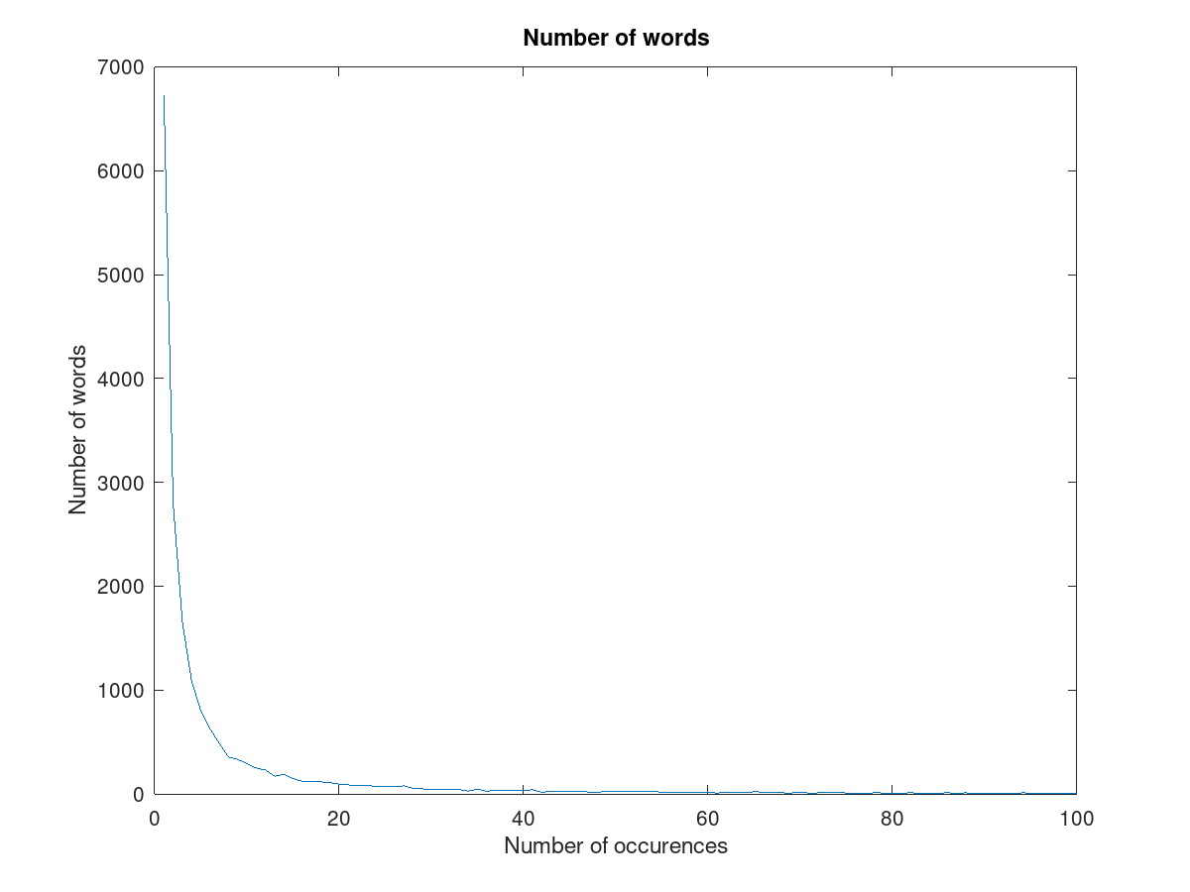

Figure x- Number of words which occur between 1 and 100 times throughout the text.

## **First and last appearances**

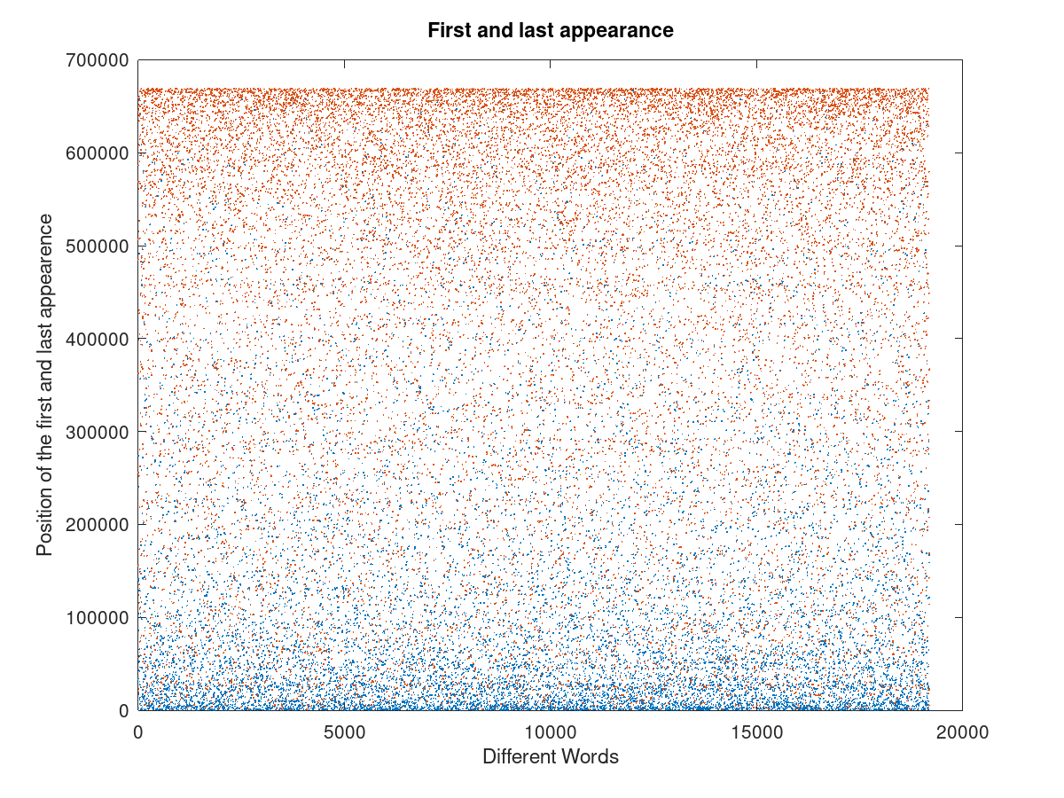Figure x- First (blue) and last (orange) appearances of different words in the text

As expected, the position of the first appearance of a word is concentrated on the first 50000 words while the last appearance is concentrated on the last 50000 too. Still there are a considerable big number of words which appear, for the first or the last time, in the middle of the text, this is justified given the high amount of words who occur only once or twice int the book.

## **Smallest, medium and largest distance**

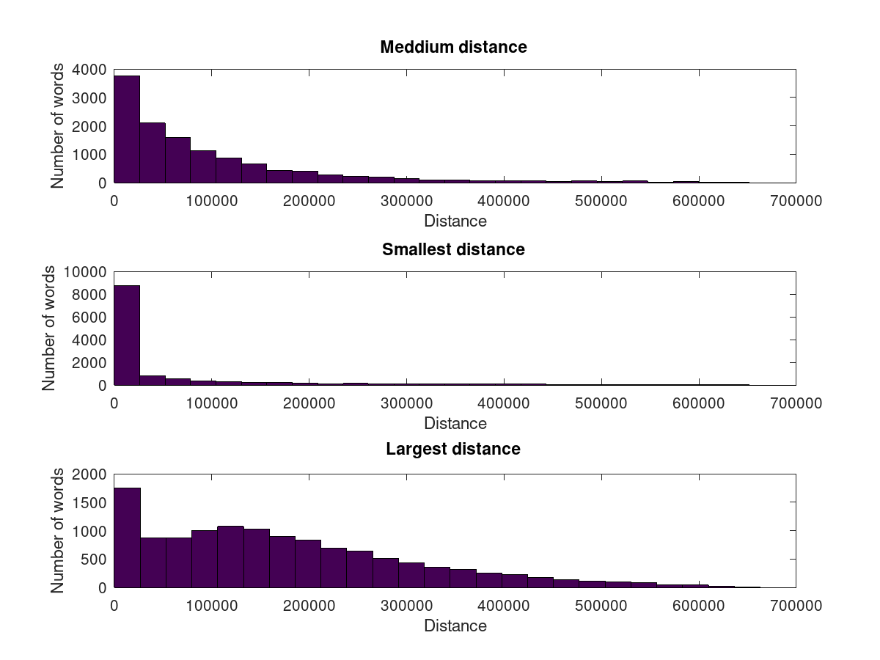

Figure x- Medium, smallest and largest distance between equal words

Almost every word has less than 100000 words as the smallest distance, however the values for the largest distance are more scattered and interestingly a considerably big number of words (~1750) has the largest distance below 25000 words. Almost 4000 words have a medium distance of less than 25000.

## **Time of execution and resize**

For both the linked list and the binary tree approach it was established that the hash tables would resize when the number of different words was bigger than 5 times the size of the hash table (this value could be bigger for the binary tree approach given the properties of the structure).

Setting the increment of the hash table size after each resize at 1000, the time of execution of the programs was measured changing the initial size of the hash table. The results are shown below (figure x).

|  |  |
| --- | --- |
| Hash table size | Resizes |
| 100 | 4 |
| 500 | 4 |
| 1000 | 3 |
| 1500 | 3 |
| 2000 | 2 |
| 2500 | 2 |
| 3000 | 1 |
| 3500 | 1 |
| 4000 | 0 |
| 5000 | 0 |

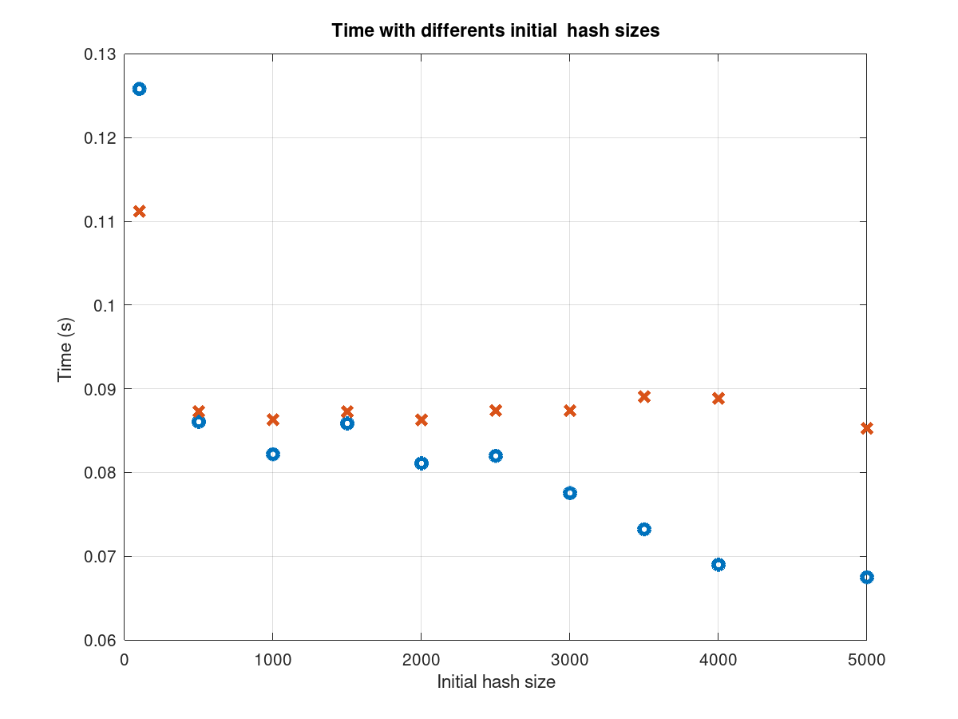

Table x – Number of resizes done for each initial hash table size

Figure x – Time of execution with different hash table sizes, for the binary tree approach (blue) and orange for the linked list approach (orange).

With the exception of the hash table size 100, in the linked list approach the time of execution is more or less constant as the hash table size increases. This doesn´t happen with the binary tree approach where we can observe that the lowest times of execution occur when there is no resize at all (4000 and 5000).

|  |  |
| --- | --- |
| Hash table size | Resizes |
| 100 | 19 |
| 200 | 10 |
| 300 | 7 |
| 400 | 5 |
| 500 | 4 |
| 800 | 3 |
| 1000 | 2 |
| 1500 | 2 |
| 2000 | 1 |
| 3000 | 1 |

